6th Grade: Unit 4, Lesson 1

- What number is the opposite of -3?

$$3$$

- Plot the number -1 on the number line.
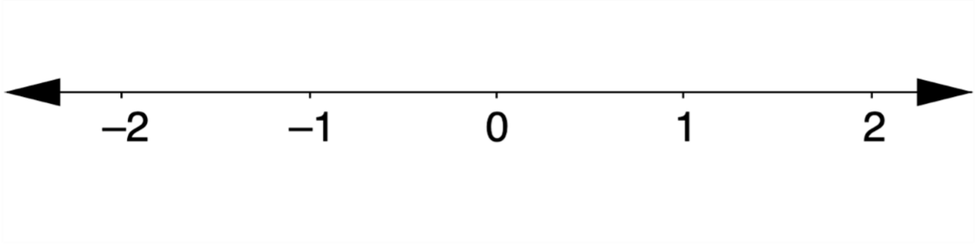

- Plot the number $\frac{1}{2}$ on the number line.


